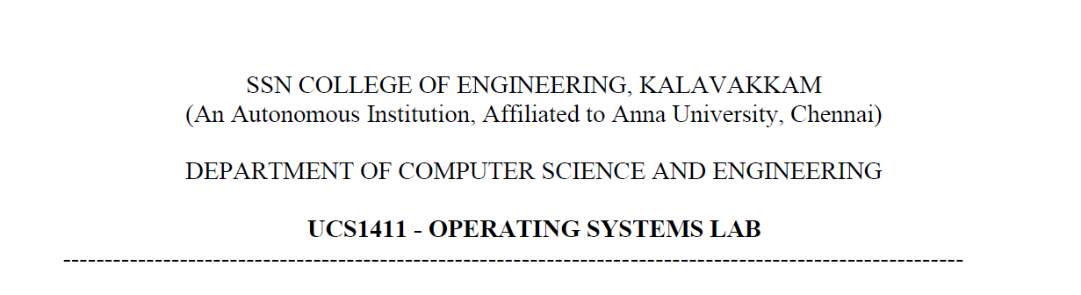

**NETWORKS LAB**

**EXERCISE 5**

Name: Jayannthan P T

Dept: CSE ‘A’

Roll No.: 205001049

DOMAIN NAME SERVER USING UDP

**Aim:**

To simulate the concept of Domain Name Server using UDP

**Algorithm:**

**SERVER**

1. Maintain a DNS in the form of table. The table contains IP address and the corresponding Server name and displays the table.

2. When a request is for an IP address (Given a server name), from a client is received, verify the table and send the corresponding IP address to the client.

3. Make server to accept multiple client request simultaneously.

4. Also modify the server.

**CLIENT**

1. Request for an IP address is given to the server by the domain name.

2. Receive the corresponding IP address and display it.

**Code:**

**Server**

#include <stdio.h>

#include <netdb.h>

#include <fcntl.h>

#include <netinet/in.h>

#include <stdlib.h>

#include <string.h>

#include <sys/socket.h>

#include <sys/types.h>

#define MAX_ADDR 10

#define MAX_DOMAIN 20

typedef **char** string[30];

typedef **struct** Entry

{

    string domain;

    string address[MAX_ADDR];

} Entry;

**void** printTable(Entry table[MAX_DOMAIN])

{

    printf("+-----------------+----------------------+\n");

    printf("|   Domain Name   |        Address       |\n");

    printf("+-----------------+----------------------+\n");

    for (**int** i = 0; i < MAX_DOMAIN; i++)

    {

        if (table[i].domain[0])

        {

            printf("| %-15s | %-20s |\n", table[i].domain, table[i].address[0]);

            for (**int** j = 1; j < MAX_ADDR && table[i].address[j][0]; j++)

                printf("| %-15s | %-20s |\n", "", table[i].address[j]);

            printf("+-----------------+----------------------+\n");

        }

    }

    printf("\n");

}

**int** checkAddress(Entry table[MAX_DOMAIN], **char** \***const** address)

{

    string addr_copy;

    strcpy(addr_copy, address);

**char** *split;

**int** val;

    split = strtok(addr_copy, ".");

    while (split)

    {

        val = atoi(split);

        if (val < 0 || val > 255)

            return -1;

        split = strtok(NULL, ".");

    }

    for (**int** i = 0; i < MAX_DOMAIN; i++)

    {

        if (!table[i].domain[0])

            continue;

        for (**int** j = 0; j < MAX_ADDR && table[i].address[j][0]; j++)

            if (strcmp(address, table[i].address[j]) == 0)

                return -2;

    }

    return 0;

}

**int** createEntry(Entry table[MAX_DOMAIN], **char** *domain, **char** *address)

{

*// Search if entry exists already*

**int** index = -1;

**int** flag = 0;

**int** addr_invalid = checkAddress(table, address);

    if (addr_invalid)

        return addr_invalid;

    for (**int** i = 0; i < MAX_DOMAIN; i++)

    {

        if (strcmp(table[i].domain, domain) == 0)

        {

            for (**int** j = 0; j < MAX_ADDR; j++)

                if (!table[i].address[j][0])

                {

                    strcpy(table[i].address[j], address);

                    flag = 1;

                    break;

                }

            break;

        }

        if (!table[i].domain[0] && index == -1)

            index = i;

    }

*// IF entry has to be created*

    if (!flag)

    {

        strcpy(table[index].domain, domain);

        strcpy(table[index].address[0], address);

        flag = 1;

    }

    return flag;

}

Entry getAddress(Entry *table, **char** \***const** domain)

{

    Entry result;

    bzero(&result, sizeof(Entry));

    strcpy(result.domain, domain);

    for (**int** i = 0; i < MAX_DOMAIN; i++)

    {

        if (strcmp(table[i].domain, domain) == 0)

        {

            for (**int** j = 0; j < MAX_ADDR; j++)

            {

                strcpy(result.address[j], table[i].address[j]);

            }

            break;

        }

    }

    return result;

}

**int** main(**int** argc, **char** **argv)

{

    Entry table[MAX_DOMAIN], result;

    bzero(table, MAX_DOMAIN * sizeof(Entry));

    if (argc < 2)

    {

        fprintf(stderr, "Error: Enter port number for server as second argument!\n");

        exit(EXIT_FAILURE);

    }

**int** PORT = atoi(argv[1]);

**int** sockfd, len;

**struct** sockaddr_in servaddr, cliadrr;

**char** buff[30];

**int** n;

    sockfd = socket(AF_INET, SOCK_DGRAM, 0);

    if (sockfd == -1)

    {

        fprintf(stderr, "Error: Socket creation failed!\n");

        exit(EXIT_FAILURE);

    }

    else

        printf("Socket creation successfull!\n");

    bzero(&servaddr, sizeof(servaddr));

*// assign IP, PORT*

    servaddr.sin_family = AF_INET;

    servaddr.sin_addr.s_addr = htonl(INADDR_ANY);

    servaddr.sin_port = htons(PORT);

*// Binding newly created socket to given IP and verification*

    if ((bind(sockfd, (**struct** sockaddr *)&servaddr, sizeof(servaddr))) != 0)

    {

        fprintf(stderr, "Error: Socket bind failed!\n");

        exit(EXIT_FAILURE);

    }

    else

        printf("Socket bind successfull\n");

    len = sizeof(cliadrr);

    createEntry(table, "google.com", "192.168.1.1");

    createEntry(table, "yahoo.com", "194.12.34.12");

    createEntry(table, "google.com", "17.10.23.123");

    printTable(table);

    string domain, address, opt;

    while (1)

    {

        recvfrom(sockfd, buff, sizeof(buff), MSG_WAITALL, (**struct** sockaddr *)&cliadrr, &len);

        result = getAddress(table, buff);

        sendto(sockfd, &result, sizeof(Entry), MSG_CONFIRM, (**struct** sockaddr *)&cliadrr, len);

**int** flag = 0;

        printf("Do you want to modify (yes/no): ");

        scanf("%s", opt);

        if (strcmp(opt, "yes") == 0)

        {

            printf("Enter domain: ");

            scanf("%s", domain);

            do

            {

                printf("Enter IP address: ");

                scanf("%s", address);

                flag = createEntry(table, domain, address);

                switch (flag)

                {

                case 1:

                    break; *// Correct IP*

                case -1:

                    printf("Invalid IP address!\n");

                    break;

                case -2:

                    printf("Duplicate IP address!\n");

                    break;

                default:

                    printf("Error!\n");

                }

            } while (flag != 1);

            printf("Updated table\n");

            printTable(table);

        }

    }

    close(sockfd);

}

**Client**

#include <netdb.h>

#include <stdio.h>

#include <stdlib.h>

#include <fcntl.h>

#include <string.h>

#include <sys/socket.h>

#define MAX_ADDR 10

#define MAX_DOMAIN 20

typedef **char** string[30];

typedef **struct** Entry

{

    string domain;

    string address[MAX_ADDR];

} Entry;

**void** printTable(Entry table[MAX_DOMAIN])

{

    printf("+-----------------+----------------------+\n");

    printf("|   Domain Name   |        Address       |\n");

    printf("+-----------------+----------------------+\n");

    for (**int** i = 0; i < MAX_DOMAIN; i++)

    {

        if (table[i].domain[0])

        {

            printf("| %-15s | %-20s |\n", table[i].domain, table[i].address[0]);

            for (**int** j = 1; j < MAX_ADDR && table[i].address[j][0]; j++)

                printf("| %-15s | %-20s |\n", "", table[i].address[j]);

            printf("+-----------------+----------------------+\n");

        }

    }

    printf("\n");

}

**int** checkAddress(Entry table[MAX_DOMAIN], **char** \***const** address)

{

    string addr_copy;

    strcpy(addr_copy, address);

**char** *split;

**int** val;

    split = strtok(addr_copy, ".");

    while (split)

    {

        val = atoi(split);

        if (val < 0 || val > 255)

            return -1;

        split = strtok(NULL, ".");

    }

    for (**int** i = 0; i < MAX_DOMAIN; i++)

    {

        if (!table[i].domain[0])

            continue;

        for (**int** j = 0; j < MAX_ADDR && table[i].address[j][0]; j++)

            if (strcmp(address, table[i].address[j]) == 0)

                return -2;

    }

    return 0;

}

**int** createEntry(Entry table[MAX_DOMAIN], **char** *domain, **char** *address)

{

*// Search if entry exists already*

**int** index = -1;

**int** flag = 0;

**int** addr_invalid = checkAddress(table, address);

    if (addr_invalid)

        return addr_invalid;

    for (**int** i = 0; i < MAX_DOMAIN; i++)

    {

        if (strcmp(table[i].domain, domain) == 0)

        {

            for (**int** j = 0; j < MAX_ADDR; j++)

                if (!table[i].address[j][0])

                {

                    strcpy(table[i].address[j], address);

                    flag = 1;

                    break;

                }

            break;

        }

        if (!table[i].domain[0] && index == -1)

            index = i;

    }

*// IF entry has to be created*

    if (!flag)

    {

        strcpy(table[index].domain, domain);

        strcpy(table[index].address[0], address);

        flag = 1;

    }

    return flag;

}

Entry getAddress(Entry *table, **char** \***const** domain)

{

    Entry result;

    bzero(&result, sizeof(Entry));

    strcpy(result.domain, domain);

    for (**int** i = 0; i < MAX_DOMAIN; i++)

    {

        if (strcmp(table[i].domain, domain) == 0)

        {

            for (**int** j = 0; j < MAX_ADDR; j++)

            {

                strcpy(result.address[j], table[i].address[j]);

            }

            break;

        }

    }

    return result;

}

#define SA **struct** sockaddr

**int** main(**int** argc, **char** **argv)

{

    if (argc < 2)

    {

        fprintf(stderr, "Please pass port number of server as second argument!\n");

        exit(EXIT_FAILURE);

    }

**int** PORT = atoi(argv[1]);

    Entry query;

**int** sockfd, connfd;

**struct** sockaddr_in servaddr, cli;

**char** buff[30] = {0};

    sockfd = socket(AF_INET, SOCK_DGRAM, 0);

    if (sockfd == -1)

    {

        fprintf(stderr, "Error: Socket creation failed!\n");

        exit(EXIT_FAILURE);

    }

    else

        printf("Socket creation successfull!\n");

    bzero(&servaddr, sizeof(servaddr));

*// assign IP, PORT*

    servaddr.sin_family = AF_INET;

    servaddr.sin_addr.s_addr = inet_addr("127.0.0.1");

    servaddr.sin_port = htons(PORT);

**int** len = sizeof(Entry);

    while(1)

    {

        bzero(&query, sizeof(Entry));

        printf("Enter the domain name: ");

        scanf(" %[^\n]", query.domain);

        if (strcmp(query.domain, "END") == 0)

            break;

        sendto(sockfd, query.domain, sizeof(query.domain), MSG_CONFIRM, (**struct** sockaddr *)&servaddr, sizeof(servaddr));

        recvfrom(sockfd, &query, sizeof(Entry), MSG_WAITALL, (**struct** sockaddr *)&servaddr, &len);

        if (!query.address[0][0])

            printf("No entry in DNS!\n");

        else

        {

            printf("The IP Address is: \n");

            for (**int** i = 0; i < MAX_ADDR; i++)

            {

                if (query.address[i][0])

                    printf("%s\n", query.address[i]);

            }

            printf("\n");

        }

    }

    close(sockfd);

}

**Output:**

Server :

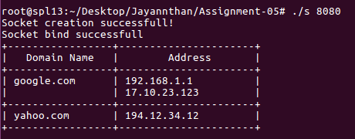

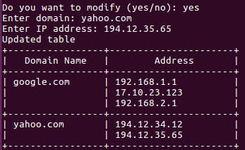 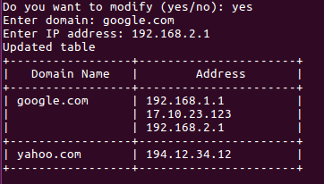

Client:

 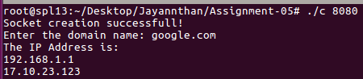

**Learning outcome:**

Learnt the working of domain name server

Learnt to simulate the working of domain name server using UDP